Lab 7  
CST8912_011  
Romeo De Guzman  
degu0055  
March 06, 2025  
Submitted to :   
Prof. Tanishq Bansal

# **Lab Report Format**

**Title**

Azure Monitoring & Alert Management

**Introduction or Purpose**

This course helps Cloud Architects analyze cloud expenditures and choose the most cost-effective service model—IaaS, PaaS, or SaaS. It introduces built-in cloud tools to track costs across different areas like Compute, Network, and Storage. By exploring cost-saving strategies, the course provides practical methods to optimize expenses with minimal changes or strategic shifts in deployment.

**Steps covered in the lab**

#### **Task 1: Deploy a Virtual Machine Using a Template**

1. Download the az104-11-vm-template.json file.
2. Sign in to the [Azure portal](https://portal.azure.com).
3. Search for **Deploy a custom template** and select **Build your own template in the editor**.
4. Load the downloaded JSON file, save it, and fill in the required fields:
   * **Subscription**: Your Azure subscription
   * **Resource Group**: CST8912 (Create new if needed)
   * **Region**: Canada Central
   * **Username**: localadmin
   * **Password**: Set a complex password
5. Click **Review + Create**, then **Create**.
6. Once deployed, go to the resource group and verify that a virtual network and VM were created.

#### **Task 2: Create an Alert for VM Deletion**

1. In **Azure Monitor**, go to **Alerts** > **Create Alert Rule**.
2. Select the resource group and apply it to all VMs.
3. Under **Condition**, search for **Delete Virtual Machine** and apply it.
4. Keep default event level and status selections.
5. Leave the alert rule pane open for the next step.

#### **Task 3: Configure Alert Notifications**

1. In the alert rule settings, go to **Next: Actions** > **Create action group**.
2. Set details:
   * **Action Group Name**: Alert the operations team
   * **Display Name**: AlertOpsTeam
3. In **Next: Notifications**, choose **Email/SMS**, name it **VM was deleted**, and enter your email.
4. In **Next: Details**, set:
   * **Alert Rule Name**: VM was deleted
   * **Description**: A VM in your resource group was deleted
5. Click **Review + Create**, then **Create**.

#### **Task 4: Trigger and Verify the Alert**

1. In **Virtual Machines**, select **az104-vm0** and delete it with **Apply force delete**.
2. Check **Notifications** for deletion confirmation.
3. Verify the alert email from [**azure-noreply@microsoft.com**](mailto:azure-noreply@microsoft.com).
4. In **Azure Monitor**, go to **Alerts** to review triggered alerts.

#### **Task 5: Suppress Alerts During Maintenance**

1. In **Alerts**, go to **Alert Processing Rules** > **Create**.
2. Select the resource group and apply the rule.
3. Under **Rule Settings**, choose **Suppress notifications**.
4. Under **Scheduling**, set:
   * **Start**: Today, 10 PM
   * **End**: Tomorrow, 7 AM
   * **Time zone**: Local time
5. Name the rule **Planned Maintenance**, add a description, and create it.

#### **Task 6: Use Azure Monitor Log Queries**

1. In **Azure Monitor**, go to **Logs** and select your resource group.
2. In **Queries**, select **Virtual Machines** and run the **Count heartbeats** query.
3. Replace the query with:

InsightsMetrics

| where TimeGenerated > ago(1h)

| where Name == "UtilizationPercentage"

| summarize avg(Val) by bin(TimeGenerated, 5m), Computer

| render timechart

1. Run and analyze the query results.
2. Clean up resources and document the steps.

**Results**

Task 1 - Use a template to provision an infrastructure

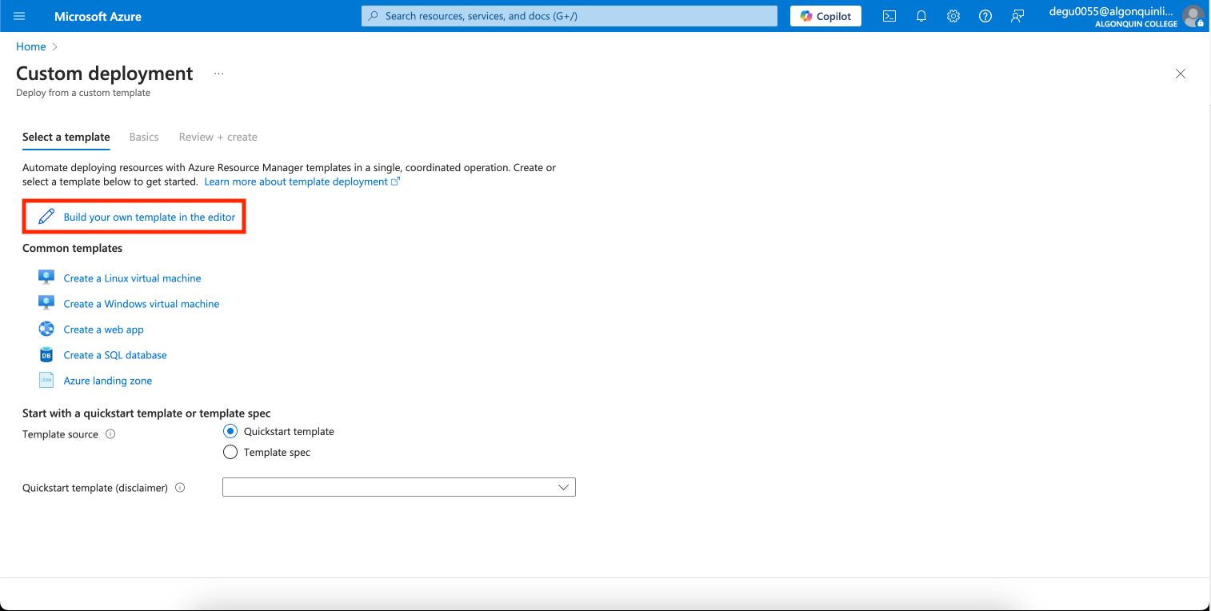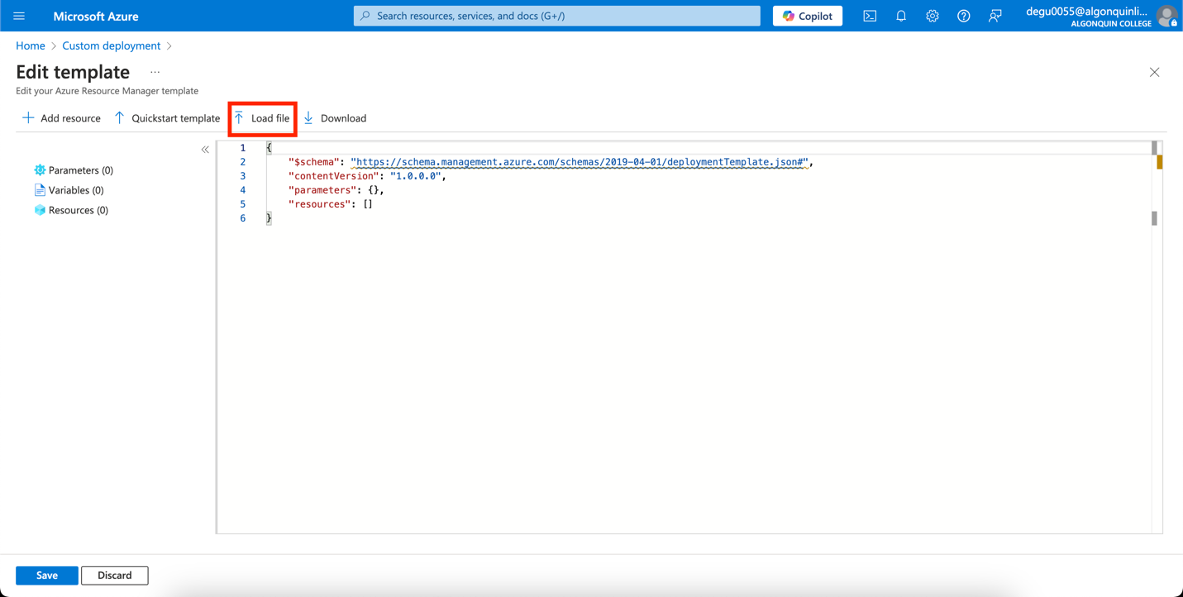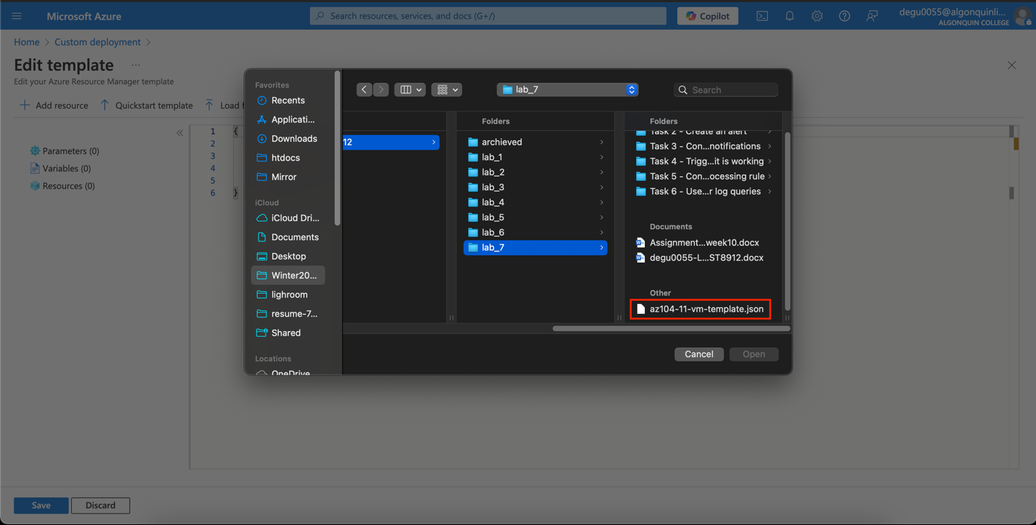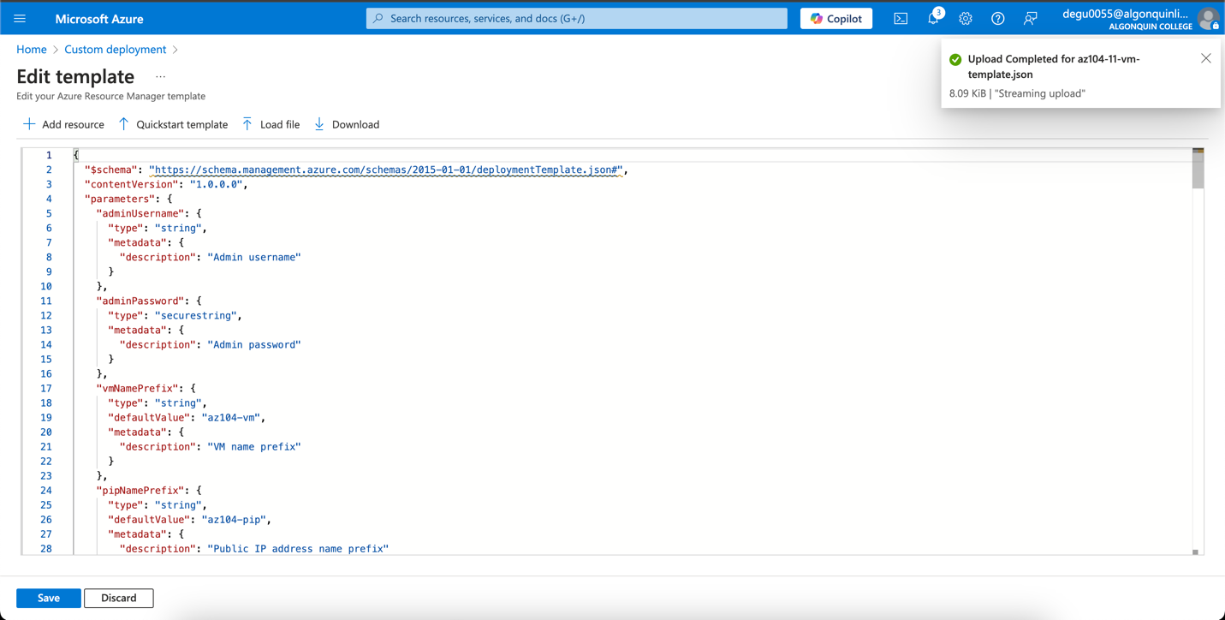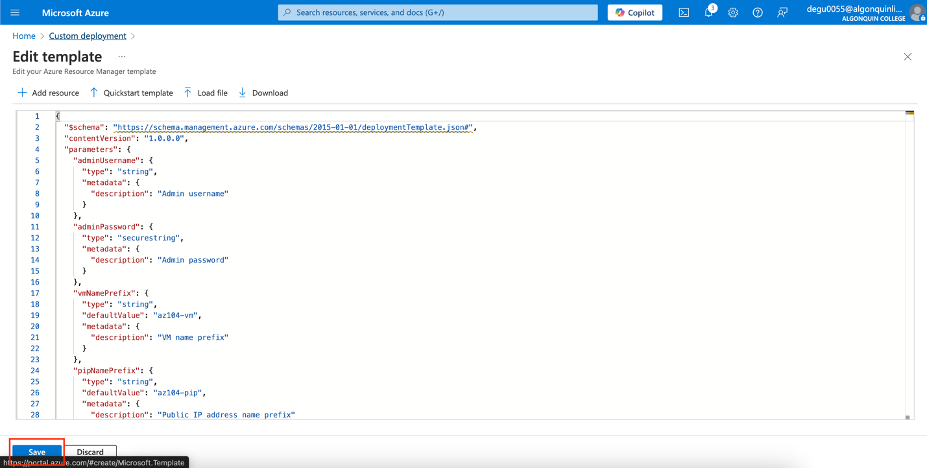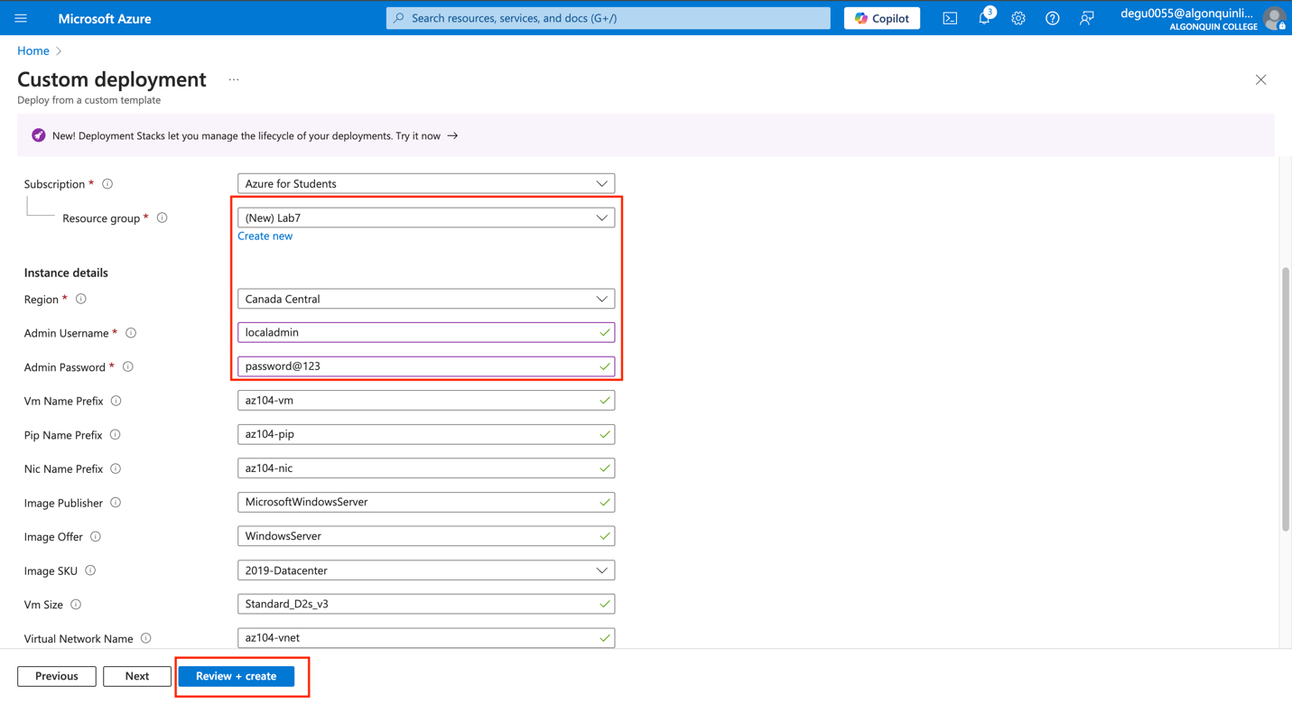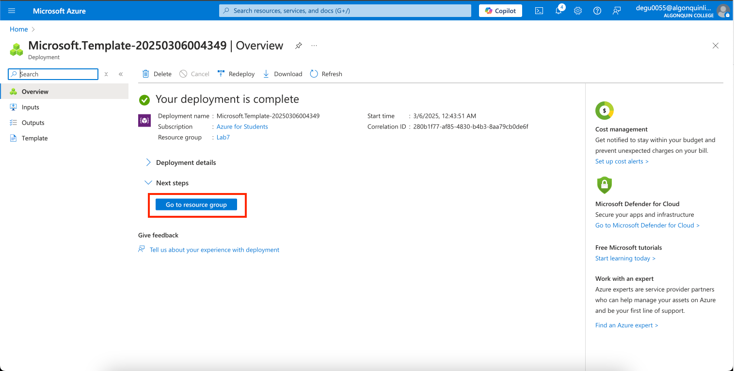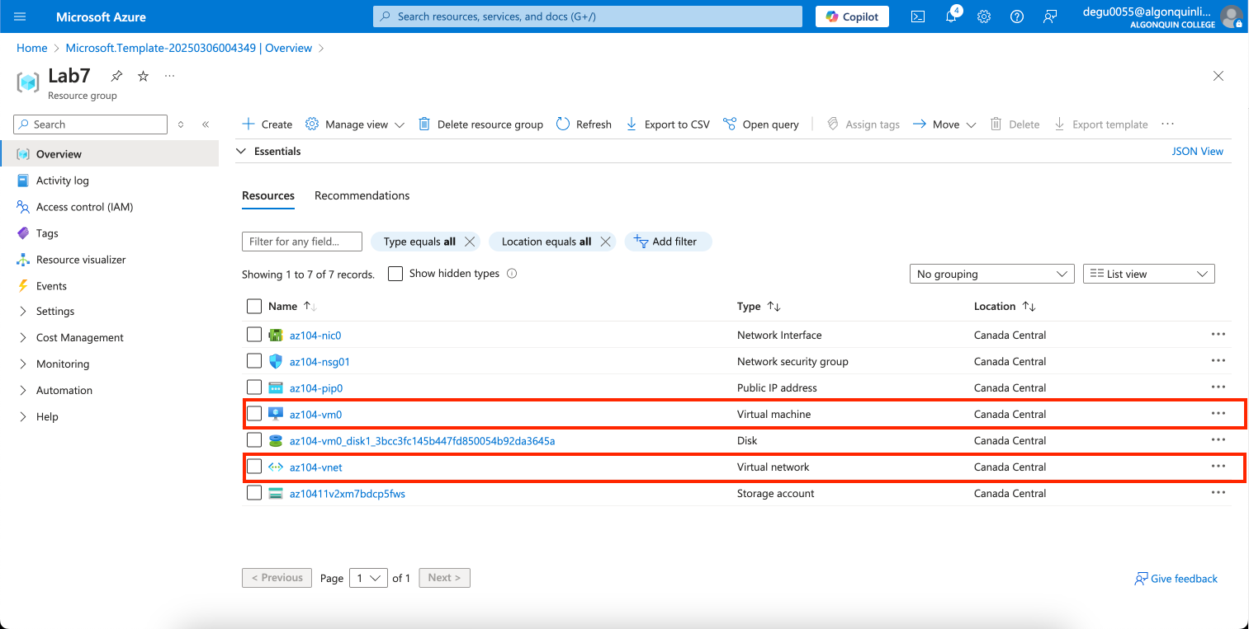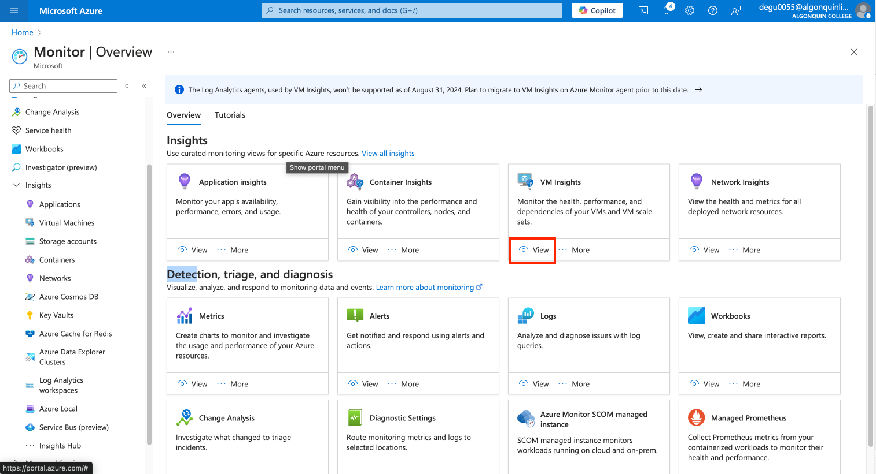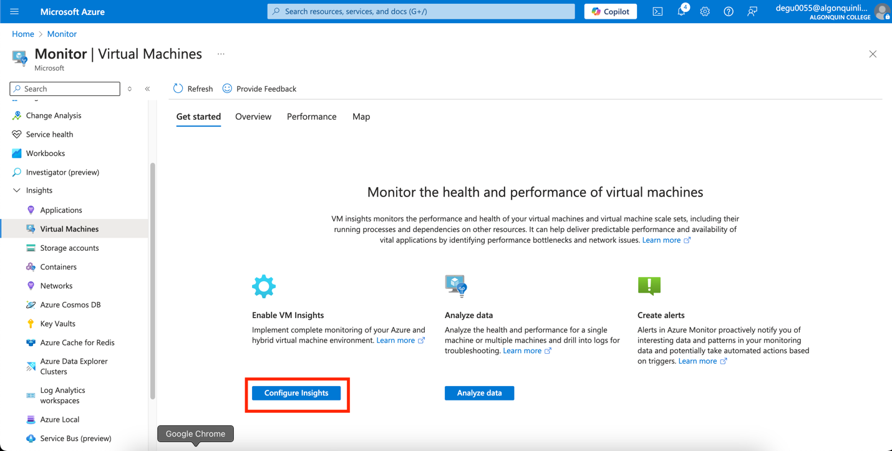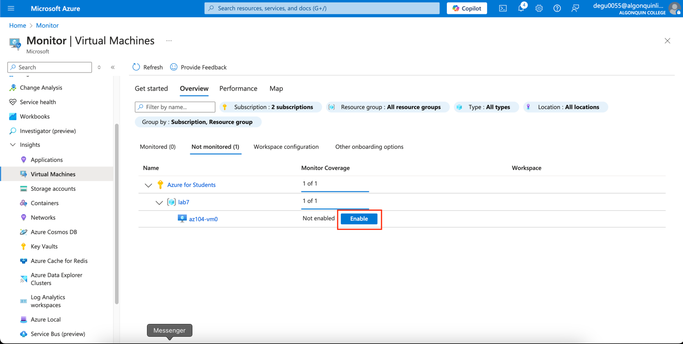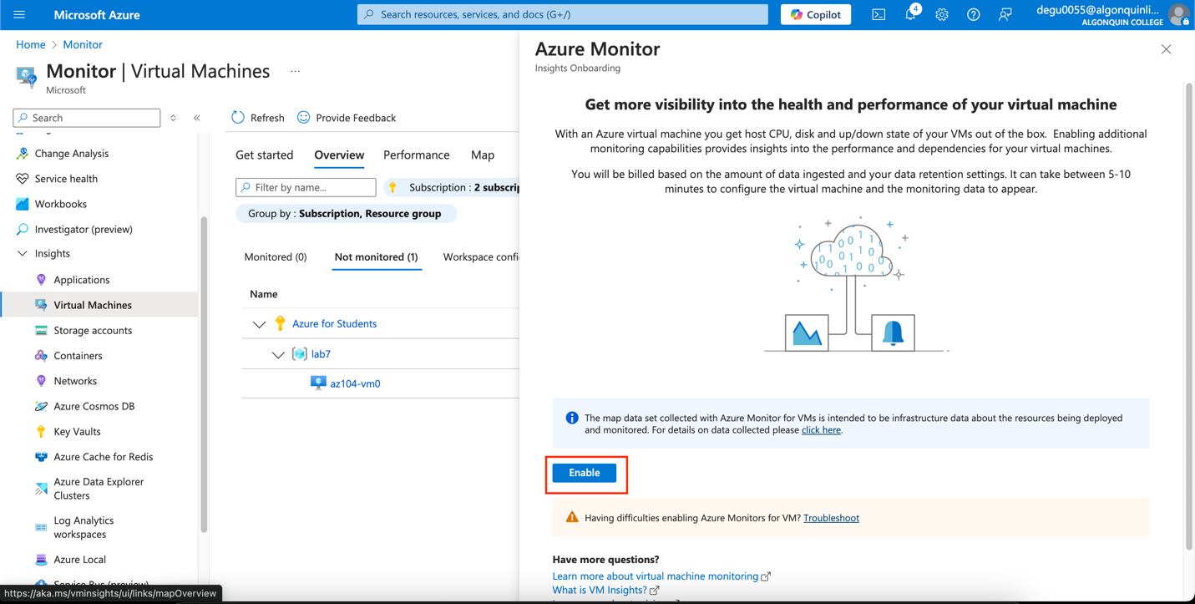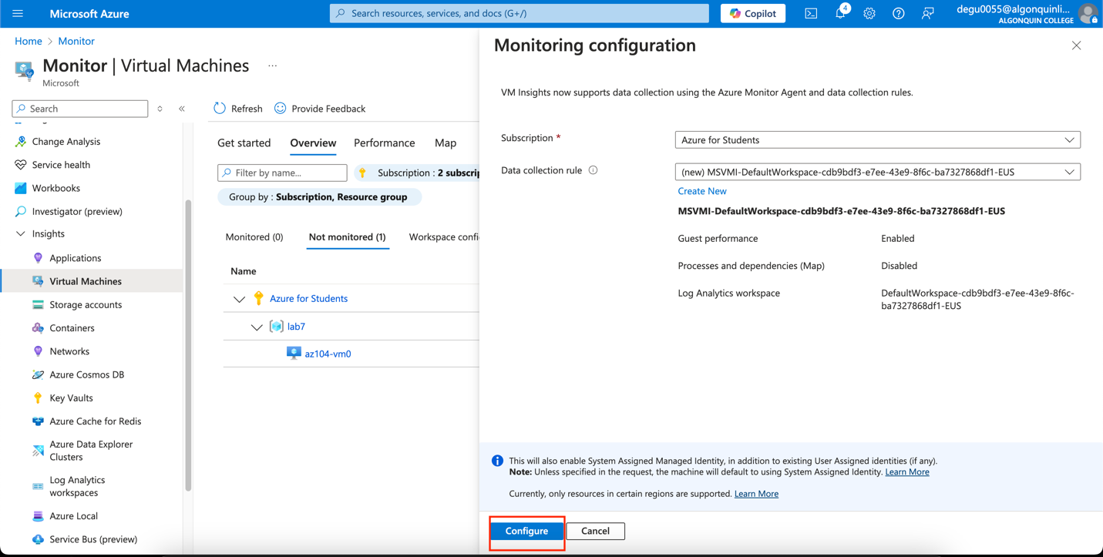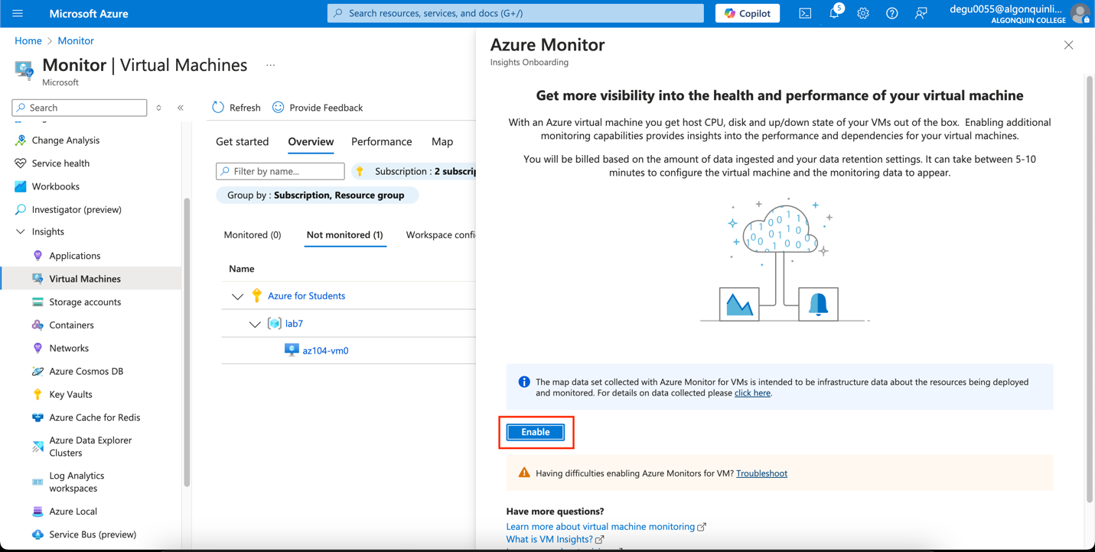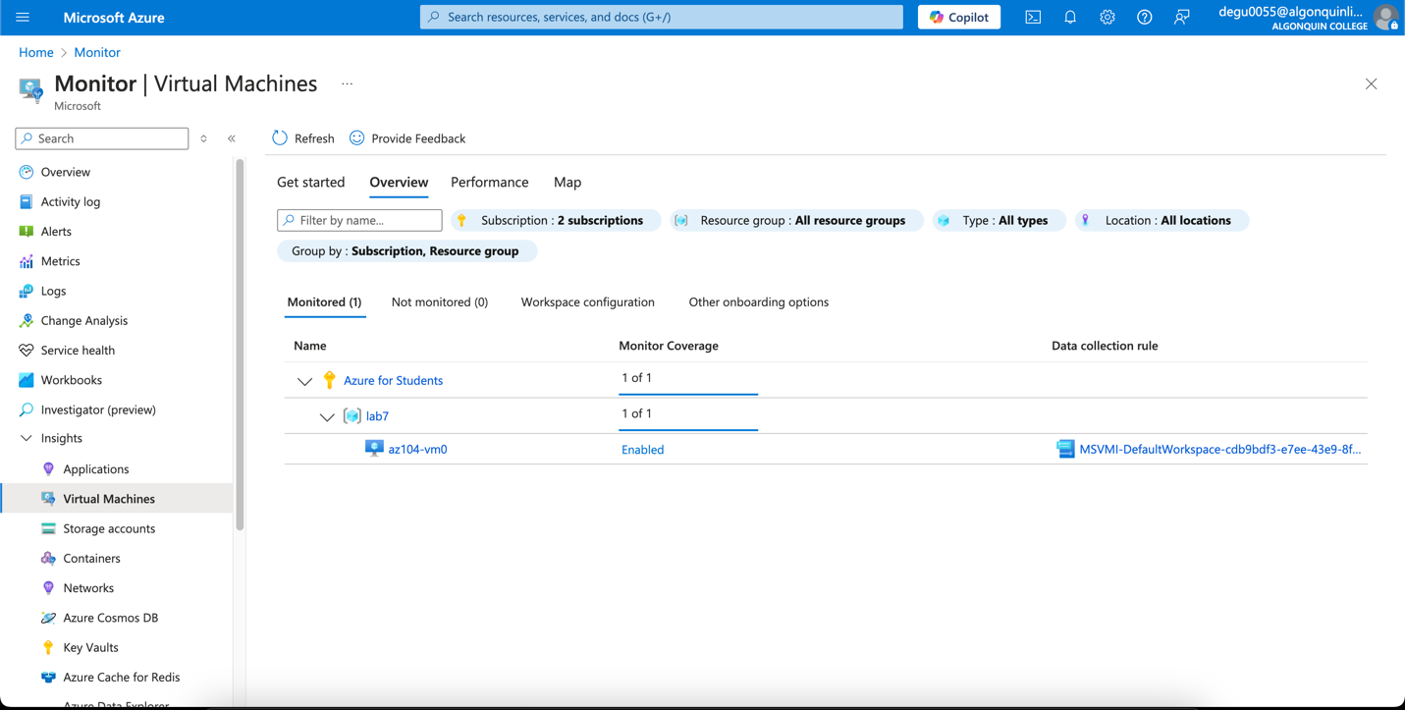

Task 2 - Create an alert

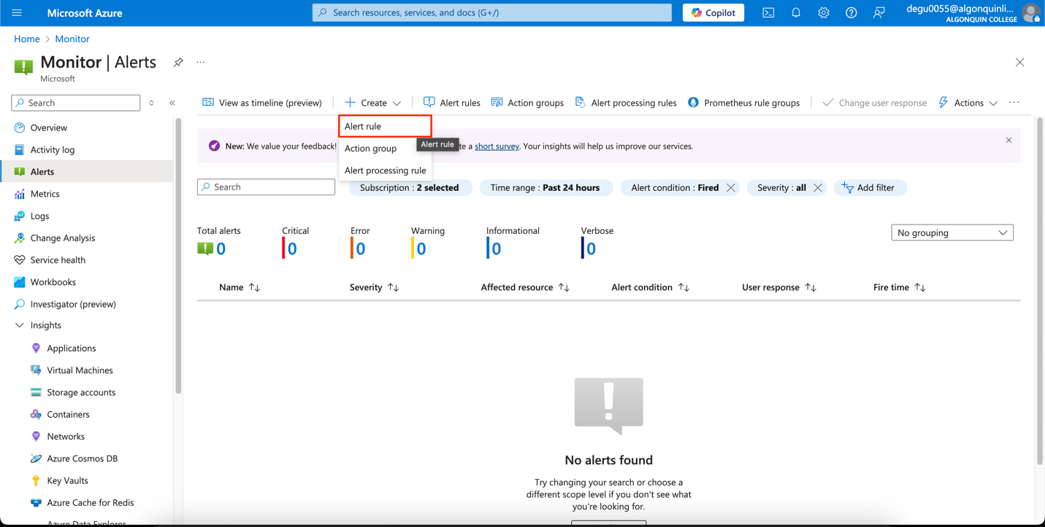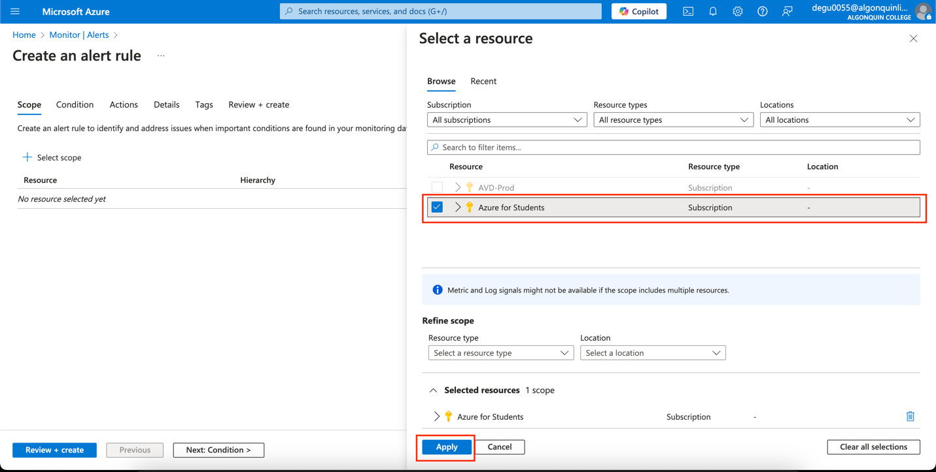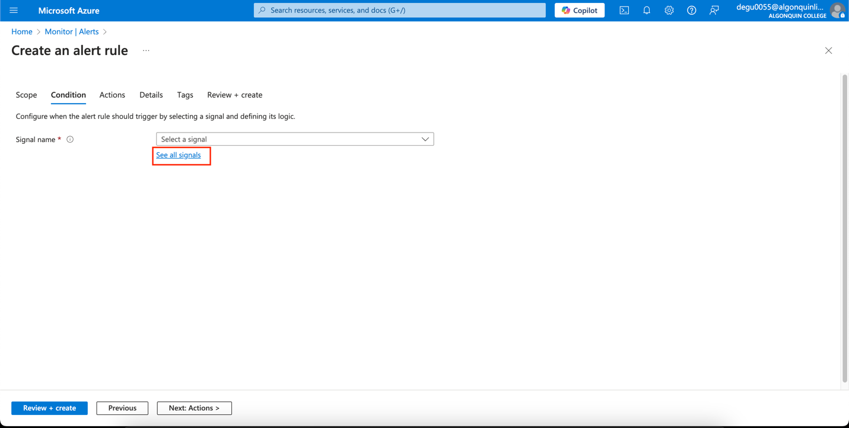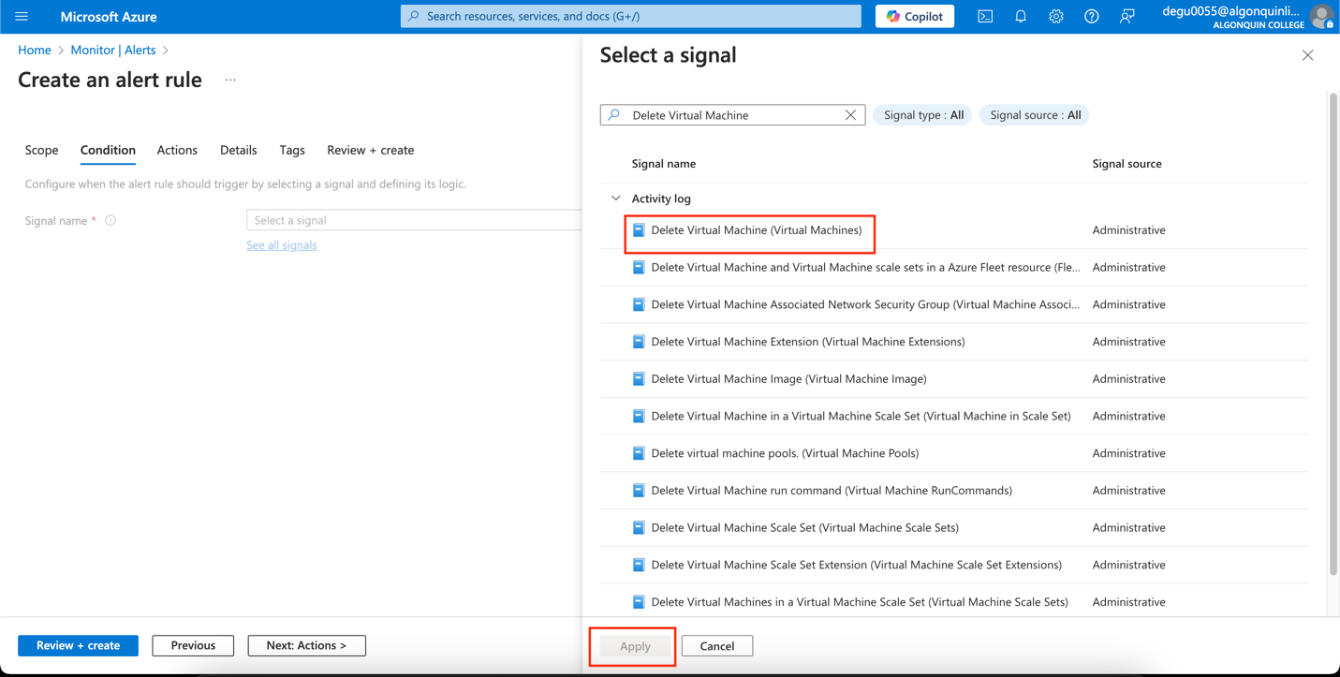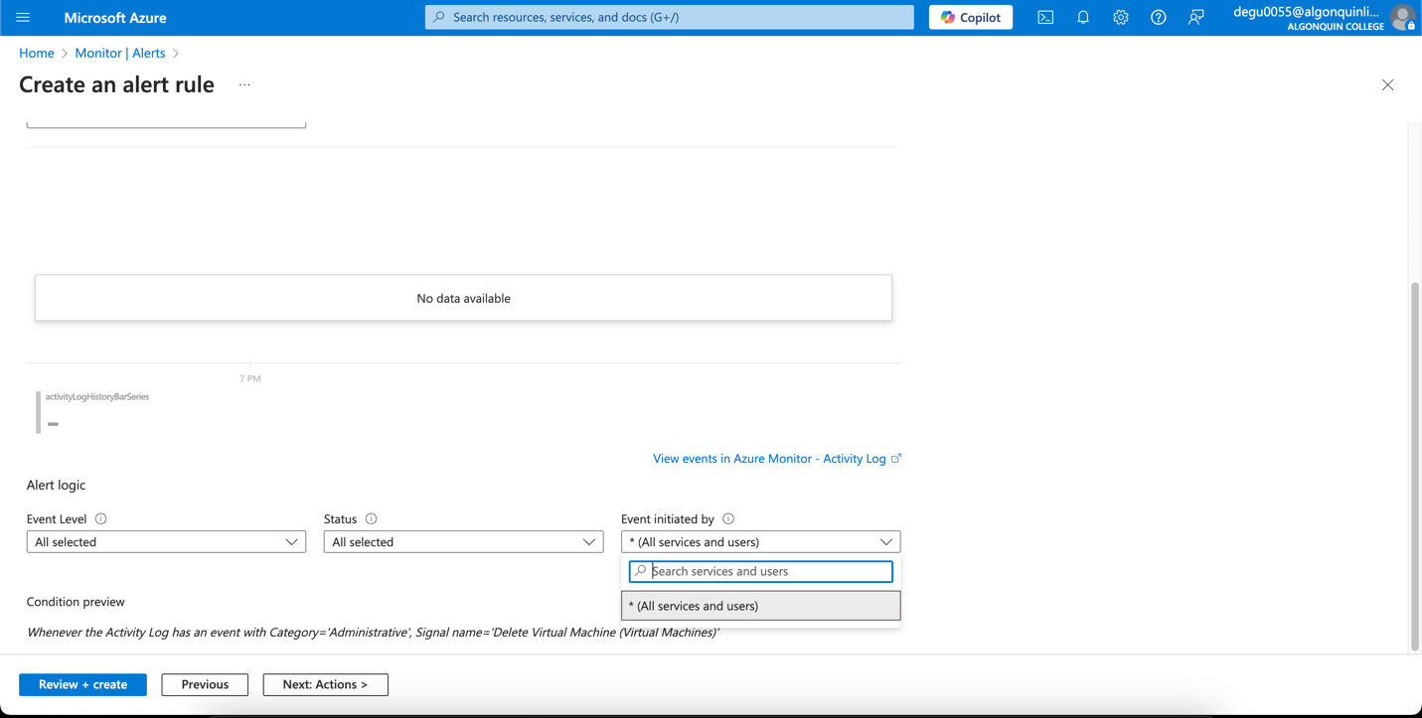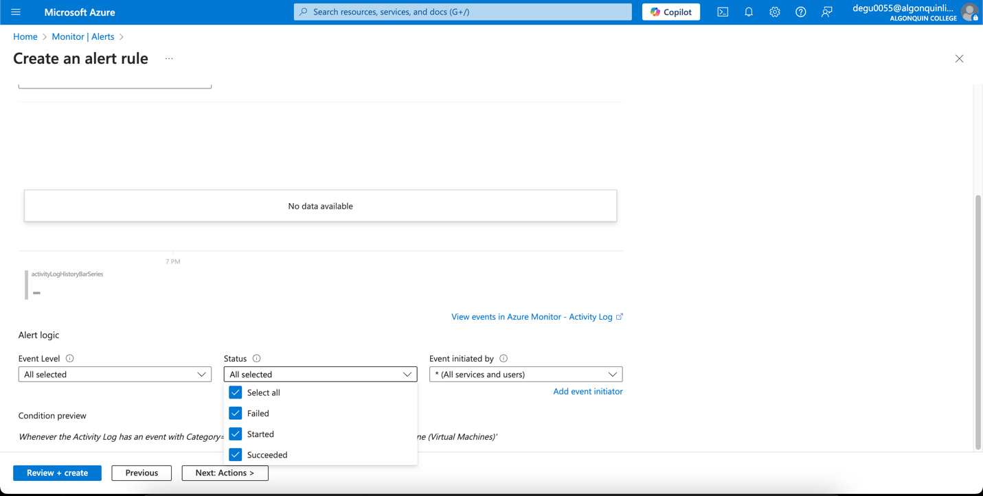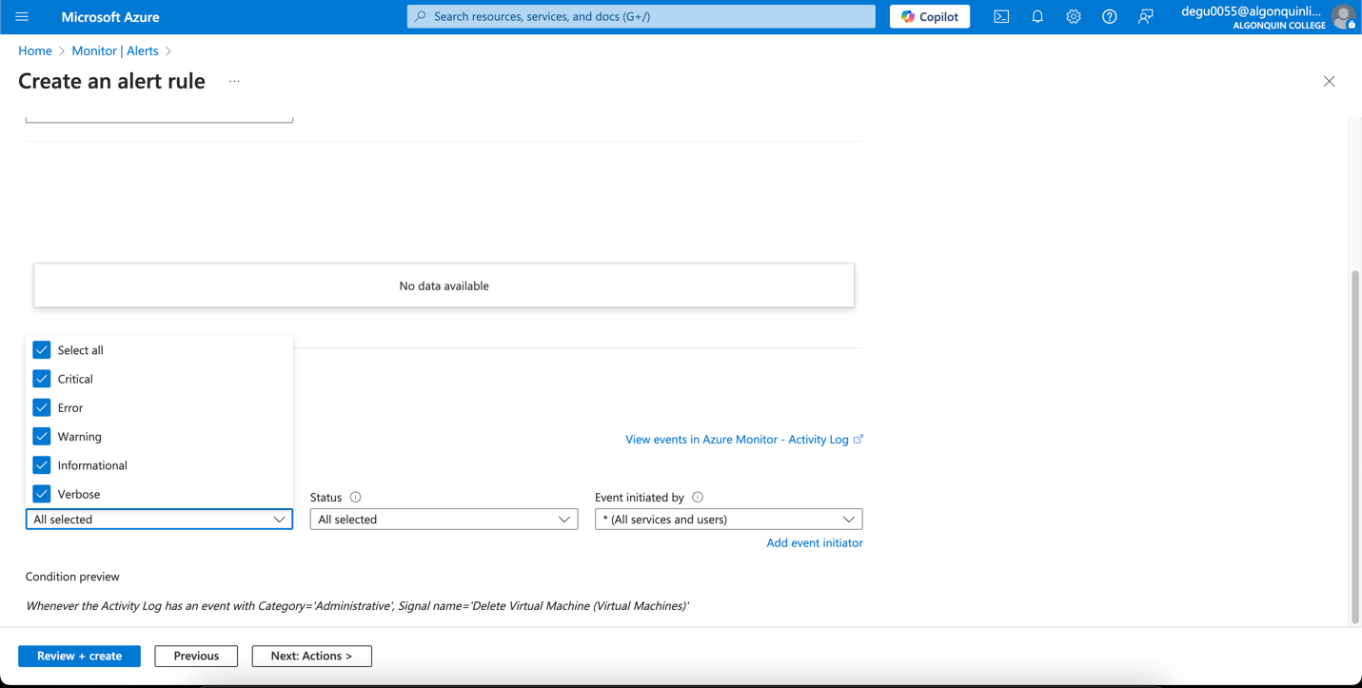

Task 3 - Configure action group notifications

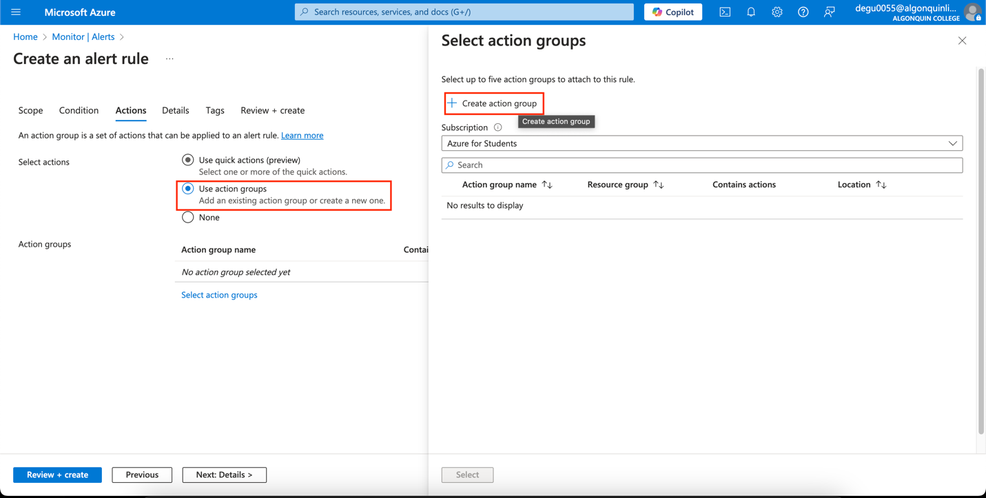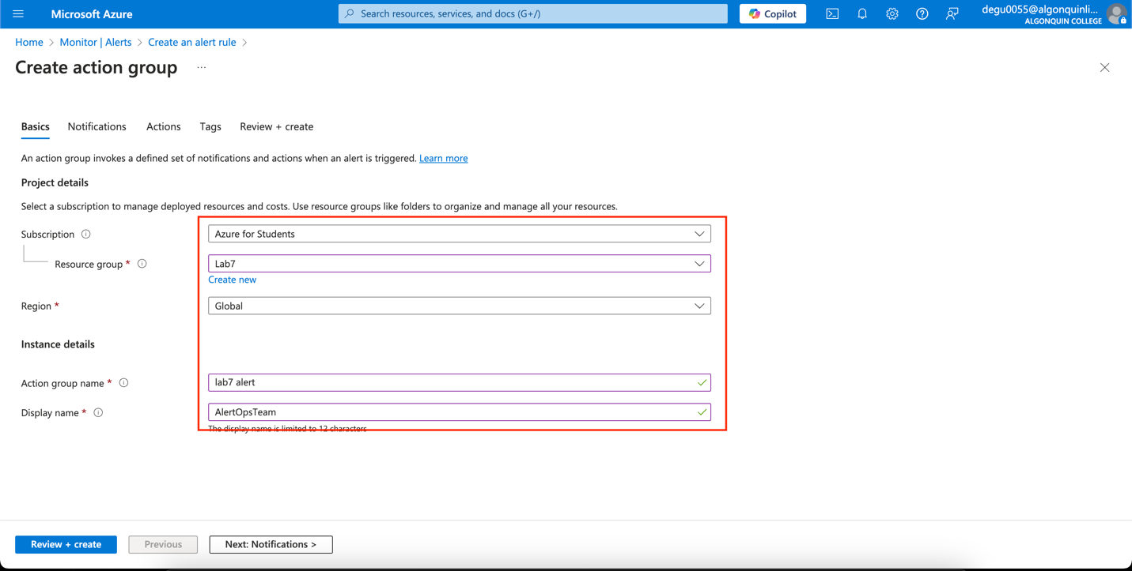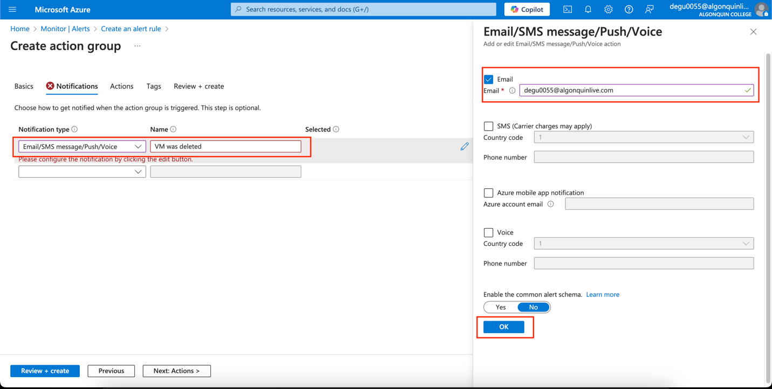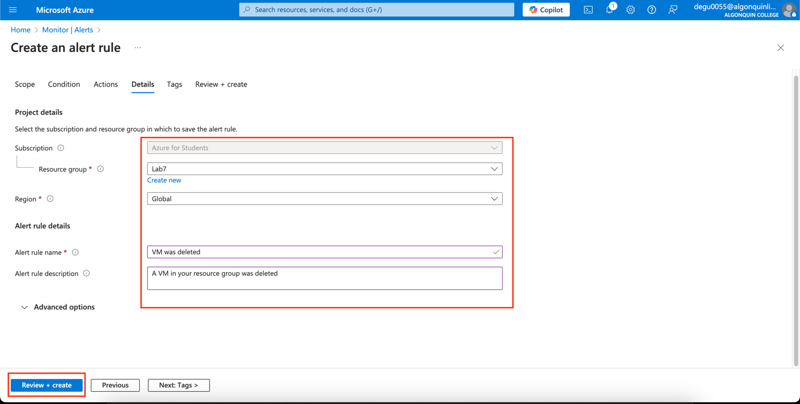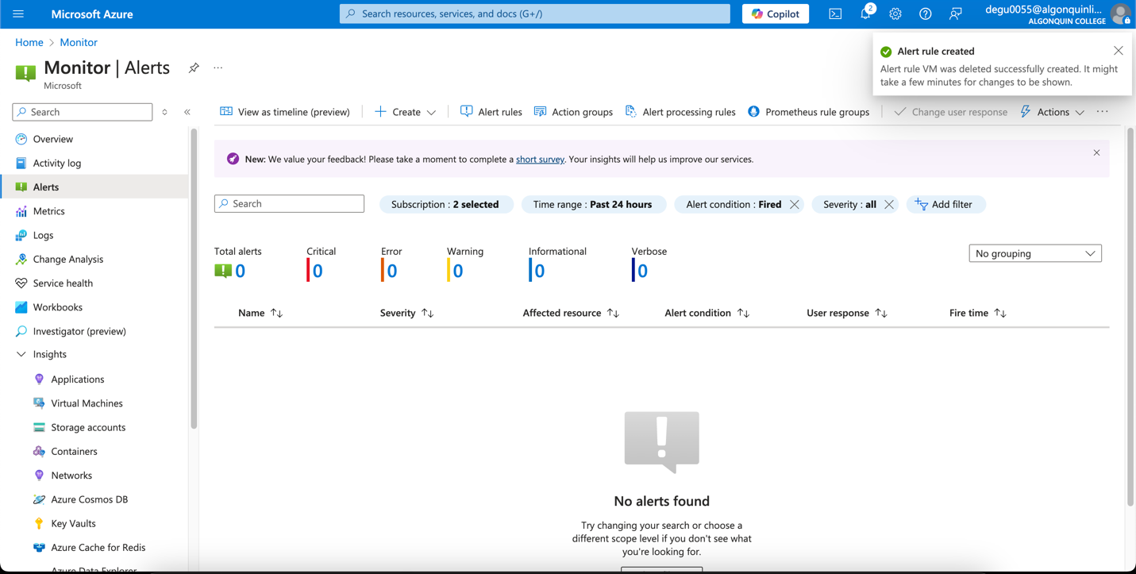

Task 4 - Trigger an alert and confirm it is working

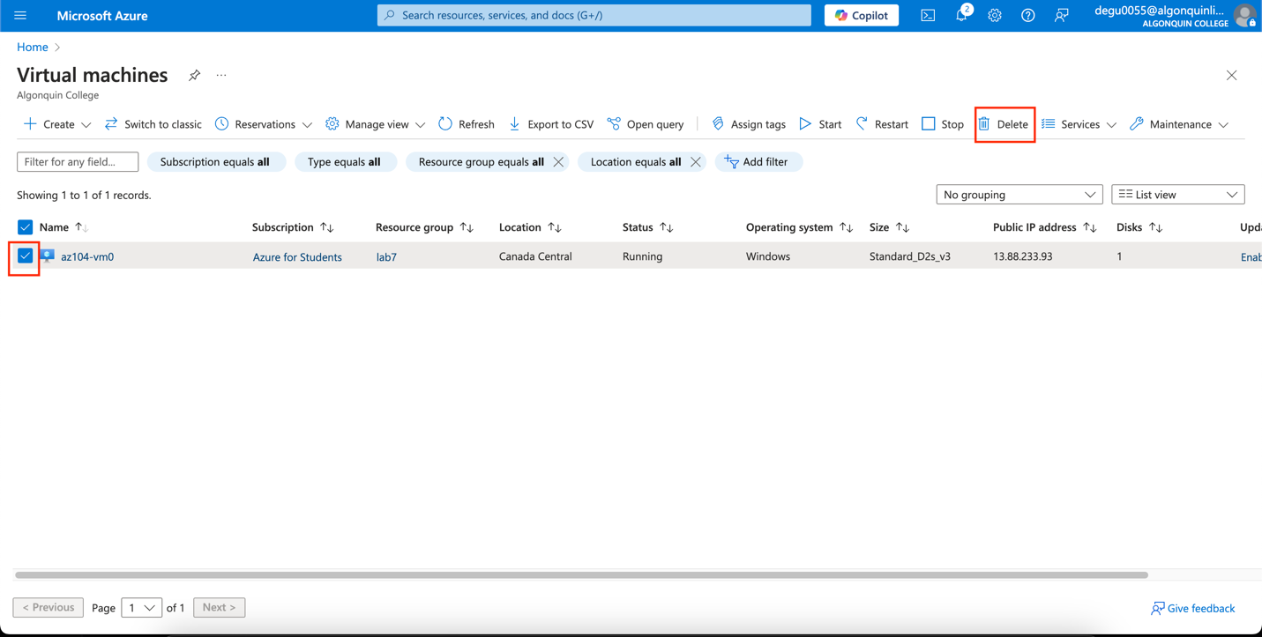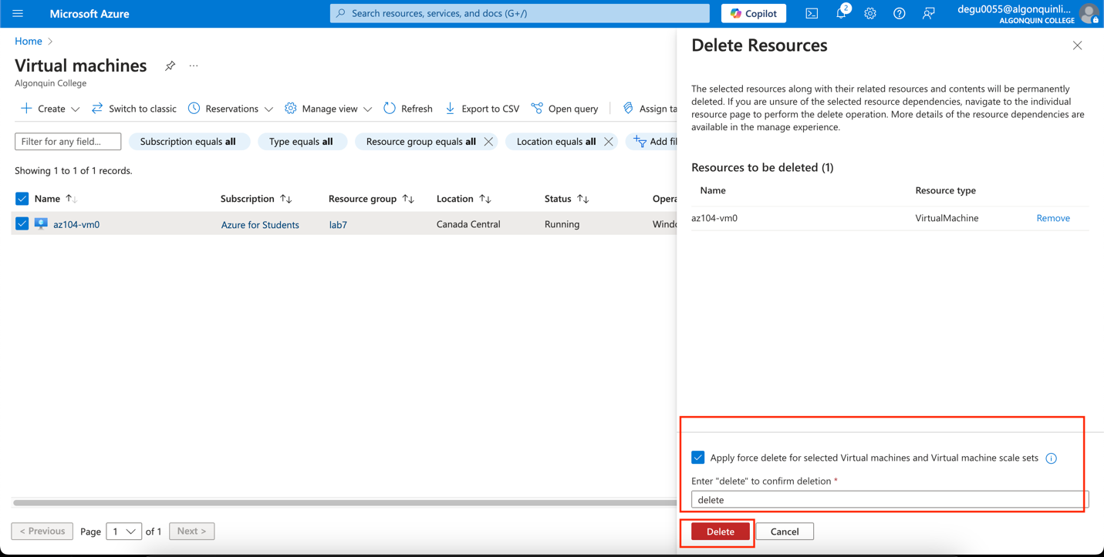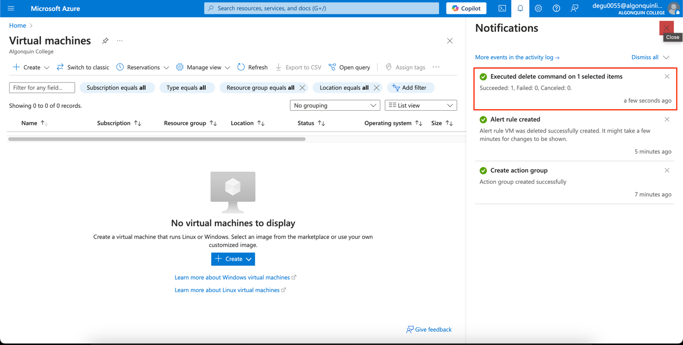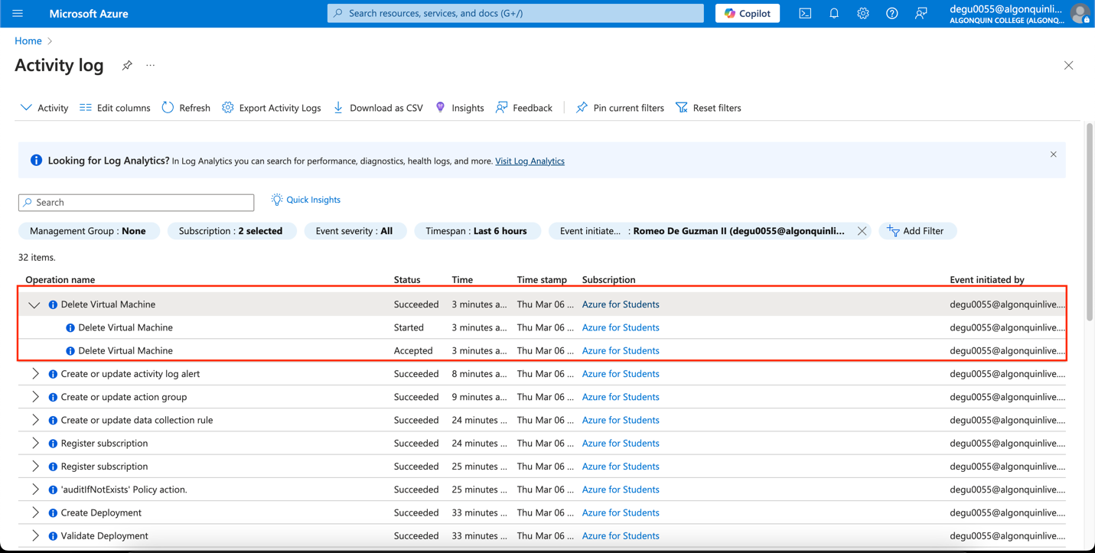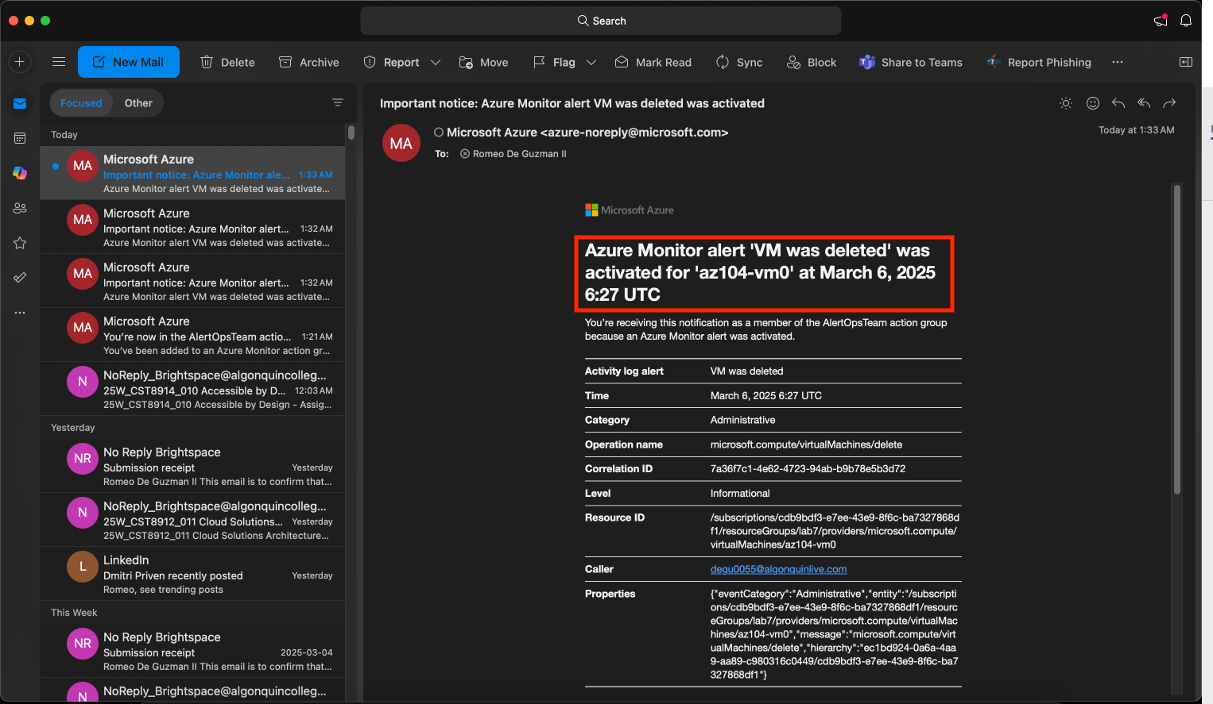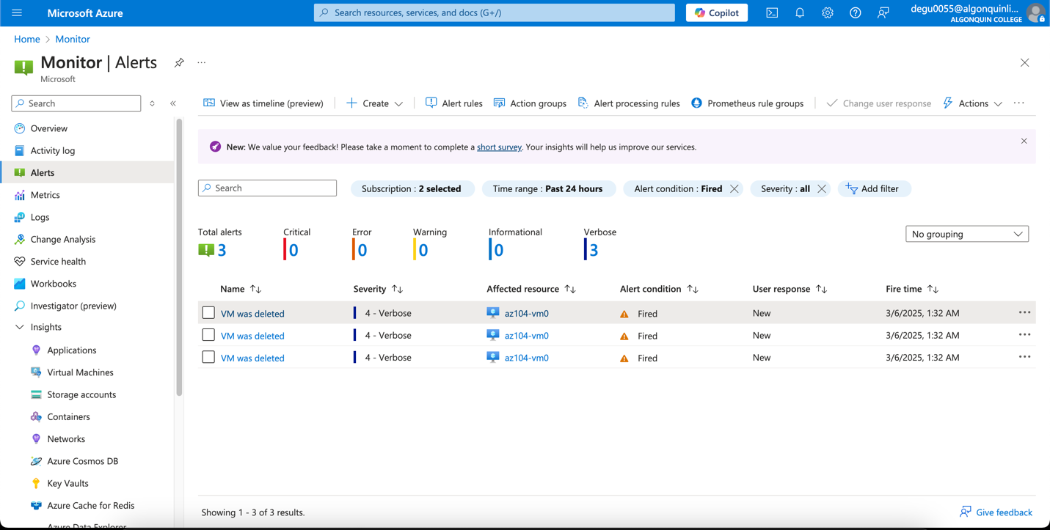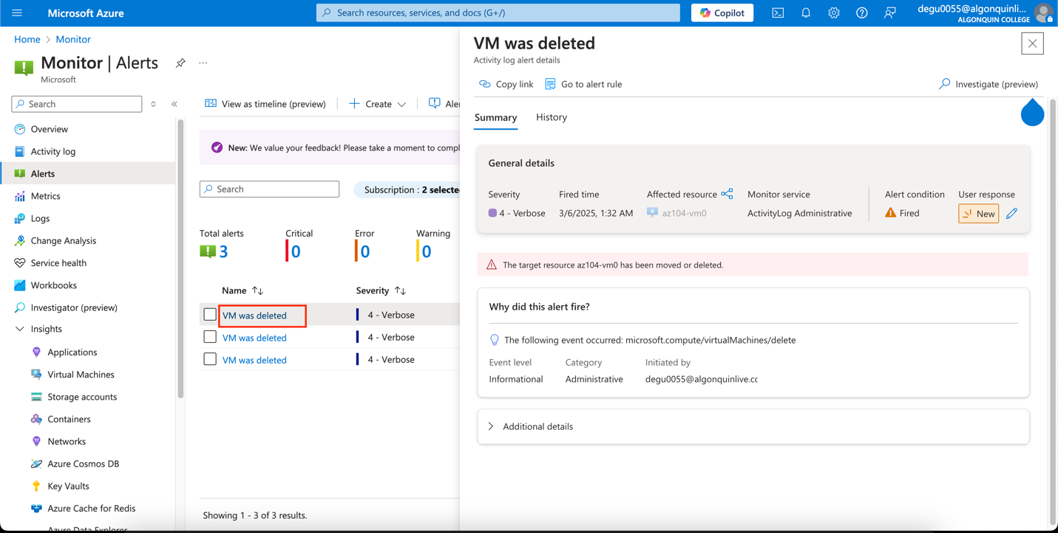

Task 5 - Configure an alert processing rule

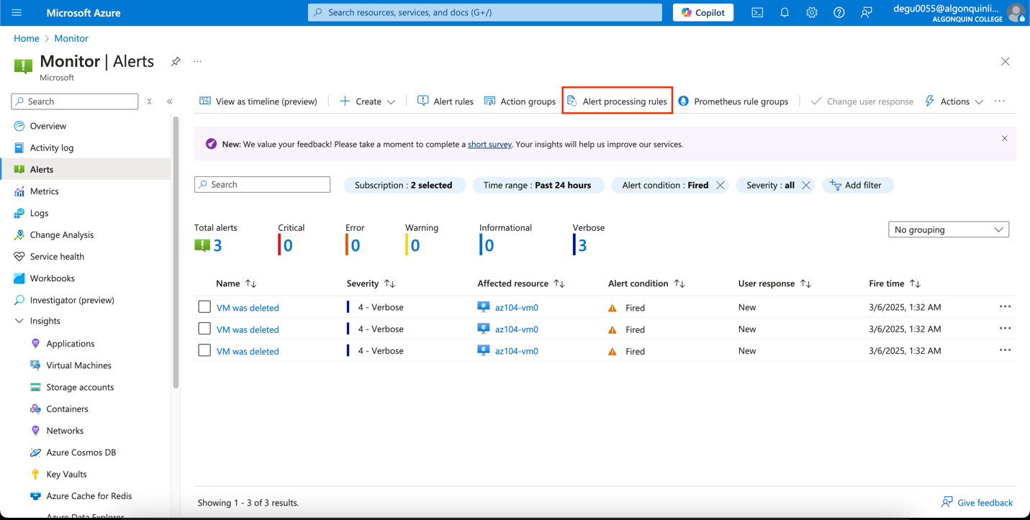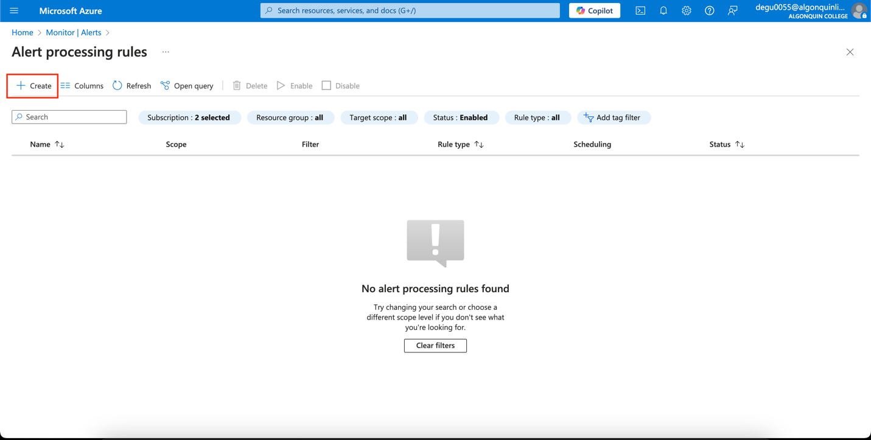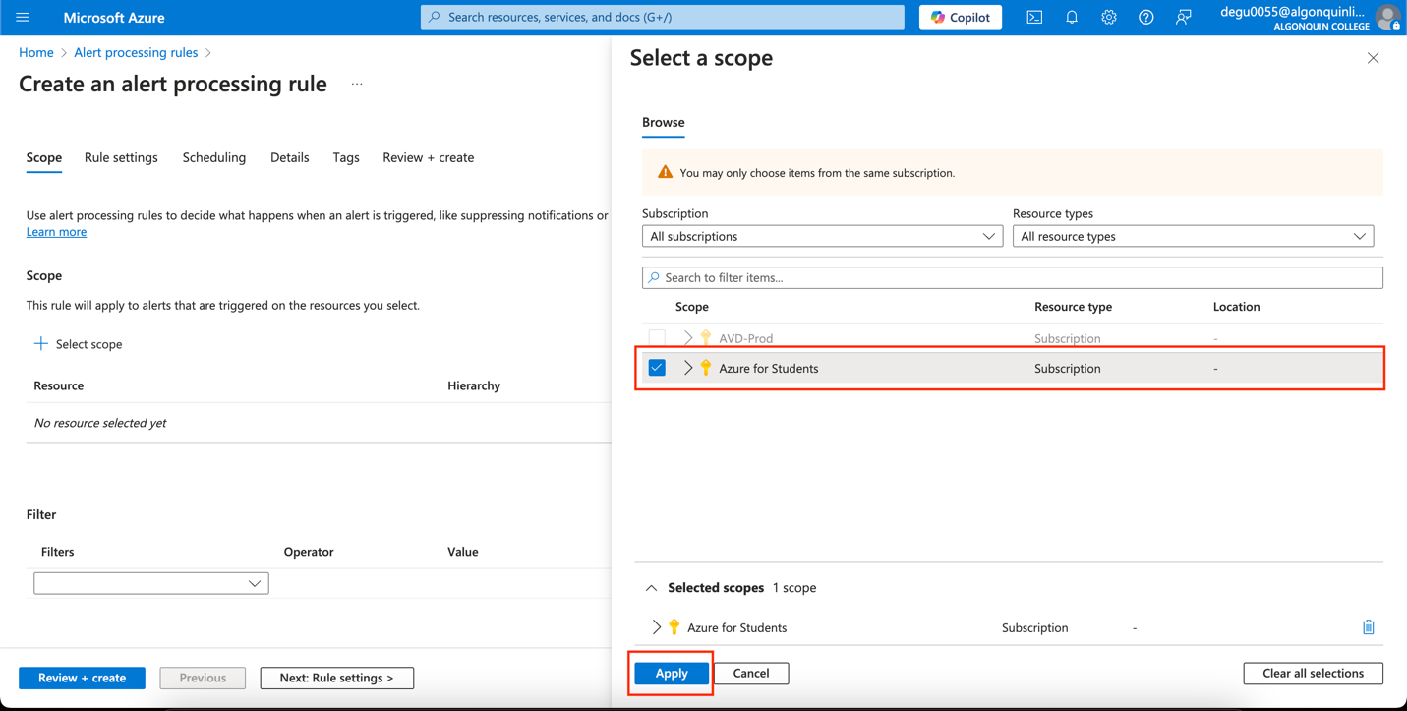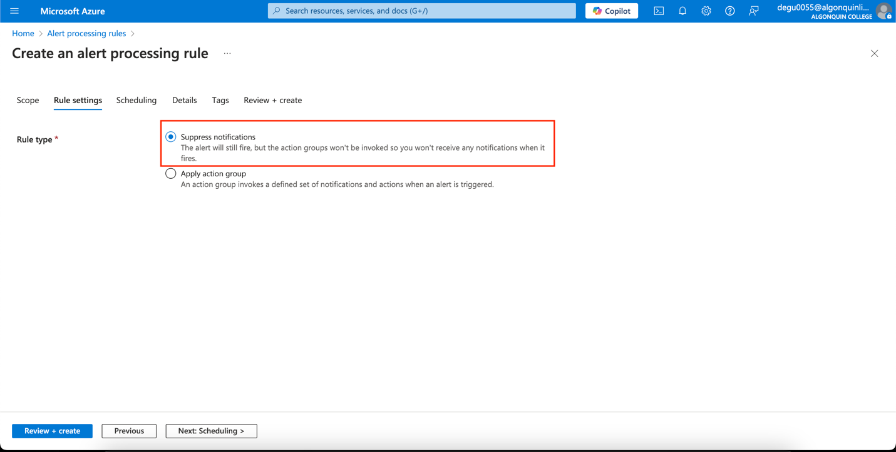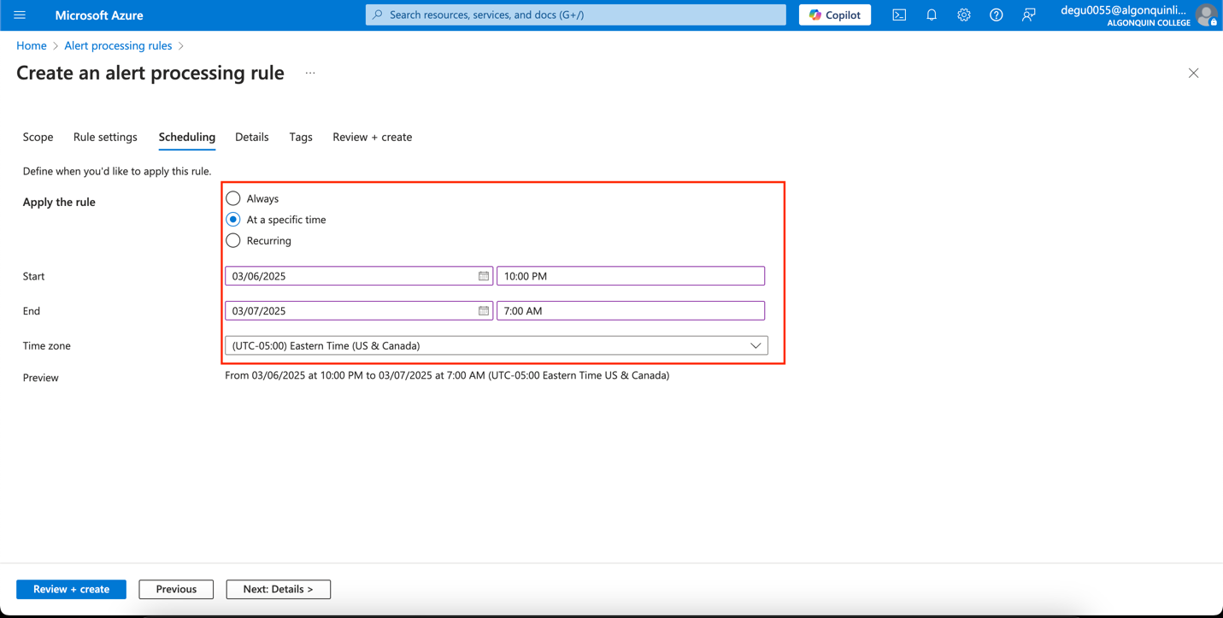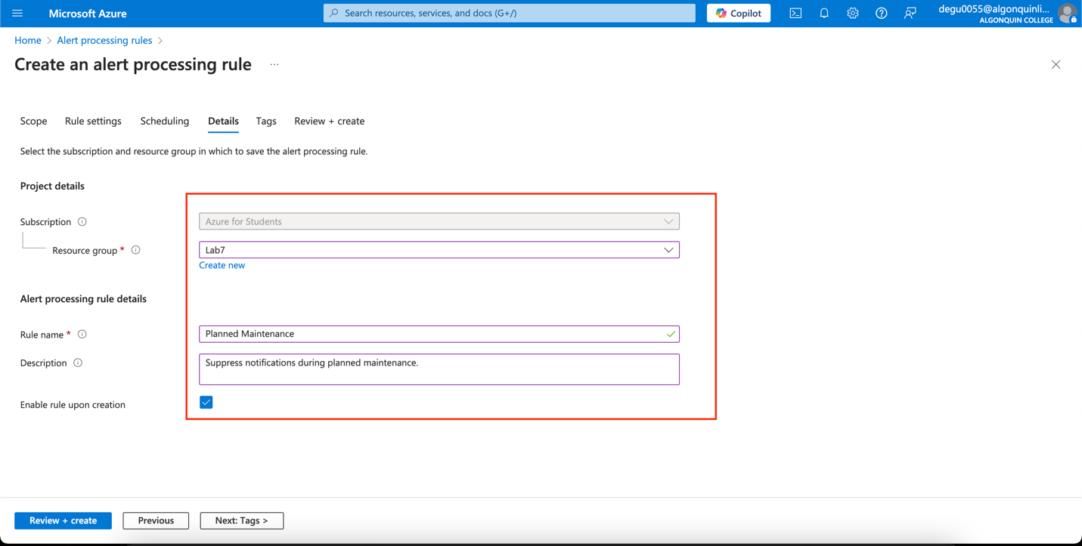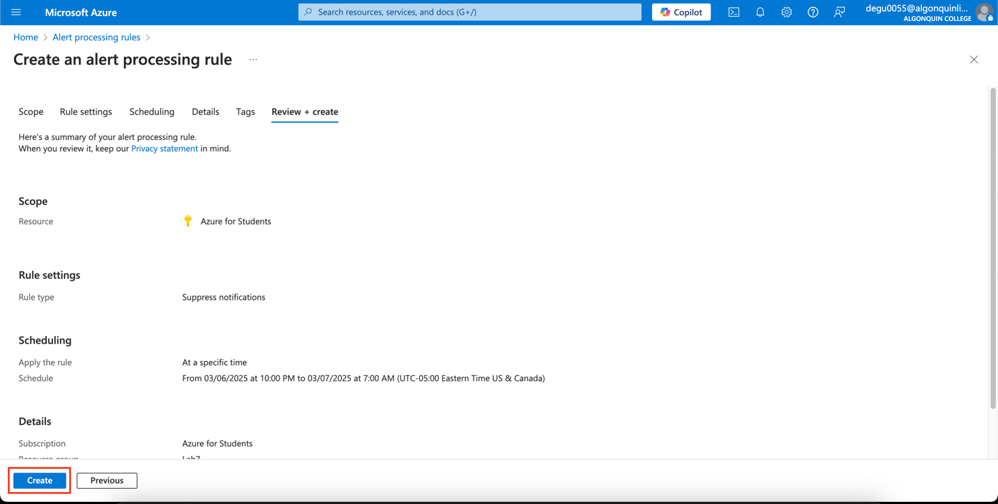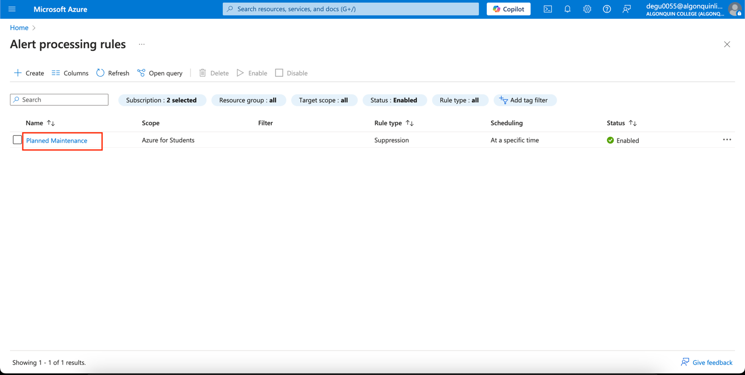

Task 6 - Use Azure Monitor log queries

